Software Design Document

Victorian State Accident

Danny Thai(s )

Sean Karl Angelo Enarbia(s5228570)llll

Table of Contents

1.0 System Vision 3

1.1 Problem Background 3

1.2 System Overview 3

1.3 Potential Benefits 3

2.0 Requirements 4

2.1 User Requirements 4

2.2 Software Requirements 4

2.3 Use Cases 4

3.0 System Components and Software Design 5

3.1 System Components 5

3.2 Software Design 5

4.0 User Interface Design 6

# System Vision

## Problem Background

The dataset of the Victoria State Accident shows road crash statistics for the last five years from 2015 - 2020 for the state of Australia/New Zealand. All fatal crashes and injuries have been recorded during the last 5 years in reporting period. The data on the site shows the analysis of Victorian fatal and injuries data based on time, location, crash types, road type users, object hit, etc. This dataset relates to different types of crashes or injuries of the people during this period. The dataset also includes the alcohol accident referring to different alcohol type accidents and provides the impact on alcohol or any other type of fatal accidents.

## System Overview

The overview of this system is provided in a software program to display a dataset about the Victorian State Accident that happened over the last five years. In this software development, the system is going to provide each different dates, months, and years for each fatal or injury on the dataset. Each one also shows the different types of crashes that provide accident status, the date of when this occurred, and the time of the accident when this happened. The dataset also shows alcohol time to show if the driver has alcohol before when this accident occurs. It also shows the collision types for each accident to make an understatement of what happened during that time. So that the users can search the dataset for each accident status and show the record for the accident.

## Potential Benefits

# Requirements

## User Requirements

For the Users to interact with this software, they would need to understand the dataset of the Victorian State Accident that occurred five years ago. If the client would be able to use this software, it would be aimed at news reporters. The reasoning for the news reporters is that they would often report accidents to the traffic for the audience to learn about the accident back then till now. This dataset about the Victorian accident five years ago would be the perfect resource for the news reporters to look and see all the accidents that happens five years ago. For the users who want to use this software, there are the following functions are provided into this software:

* The users can type in the search bar for the results for all crashes and injuries within the dataset
* It also contains a list of all types of accidents, crashes, injuries and even alcohol time
* All the results show the time zone such as dates, weeks, months, and years for all accidents
* There is a function within for the users to show their specific search for what type of accident they are looking for
* There is a dropdown list listing all the accident status, dates, types, collisions, and times for each one
* For the function of the search bar containing the time zone result from any time that is within the dataset.

With this provided within the software, the user can easily research the Victorian accident without having trouble going through the search results to show the specific accident result of what happened during that time.

## Software Requirements

In this software, the following functions are to be provided:

* 1. The program shall have the dataset and accepted as one in the command line
  2. The program shall have each name of the accident include the path of the file with the levels
  3. The program of the dataset will show the results for all crashes, fatalities, and injuries in a table row
  4. There will be a search bar for the users to enter the dataset for the Victorian State Accident
  5. Entering the search bar for the dataset will show the user the result of the accident
  6. For the users to search the specific results with the function to show all types of accidents
  7. The program also shows time zones for all accidents that occurred in the dataset

## Use Cases & Use Case Diagrams

**Use Case Diagram 1**

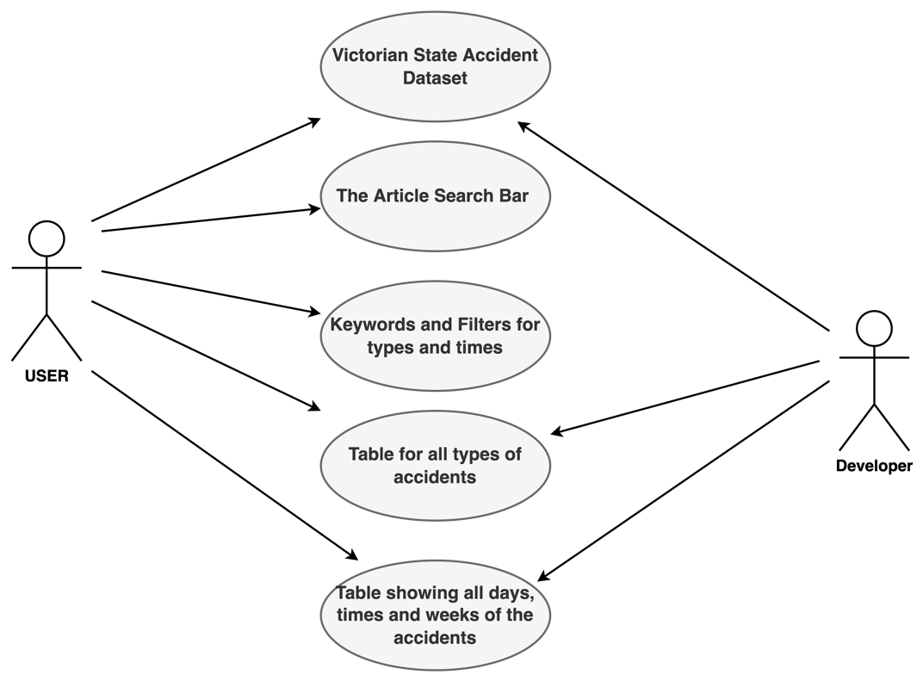

**Use Case Diagram 2**

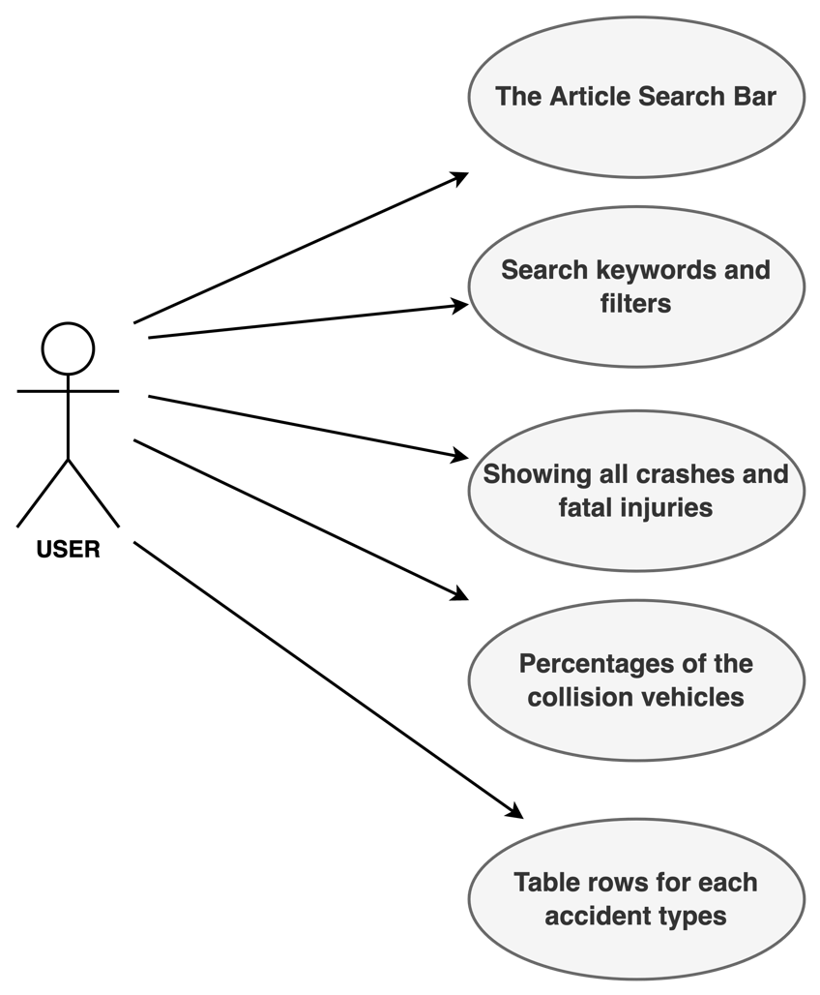

**Use Case Diagram 3**

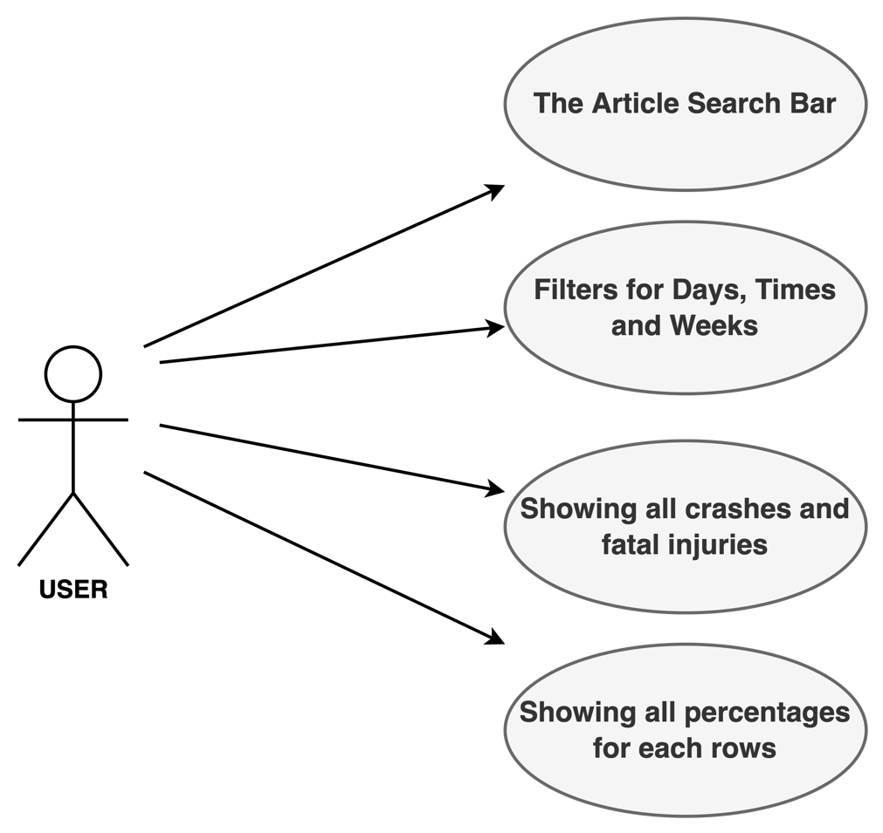

**Use Case Diagram 4**

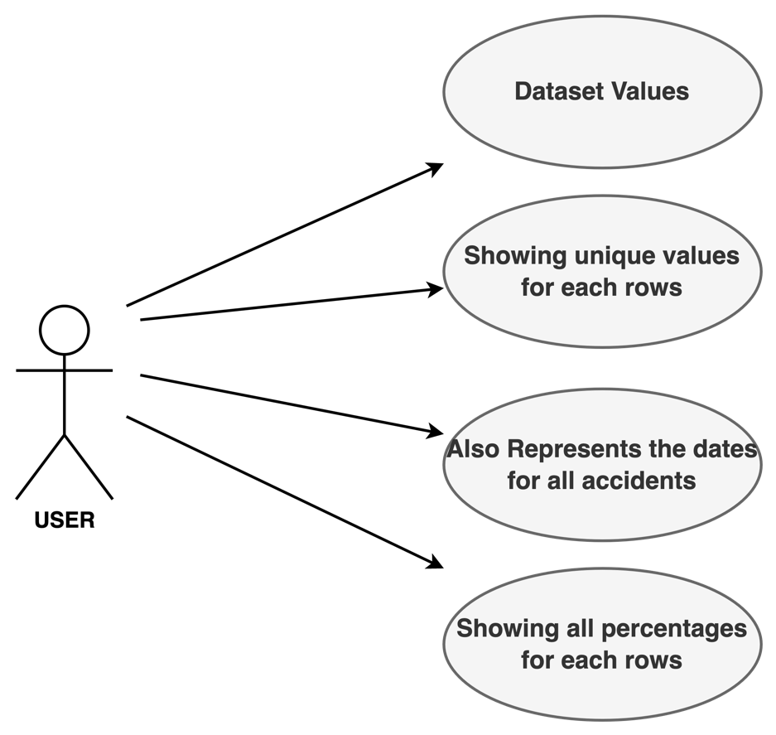

**Use Case Diagram 5**

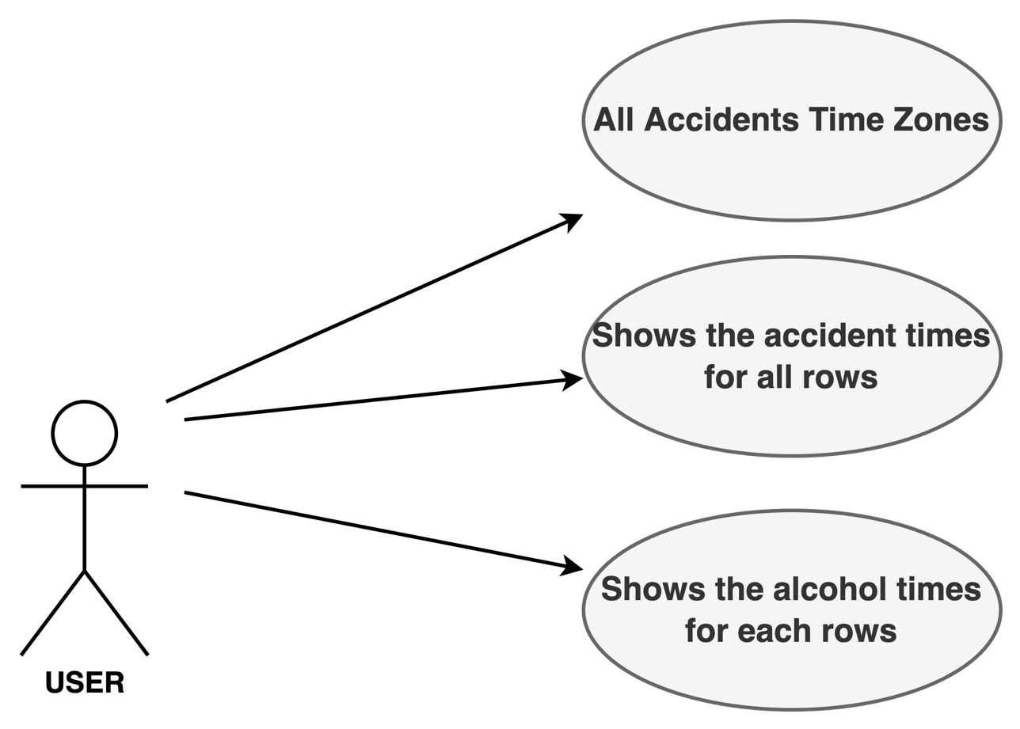

# Software Design and System Components

## Software Design

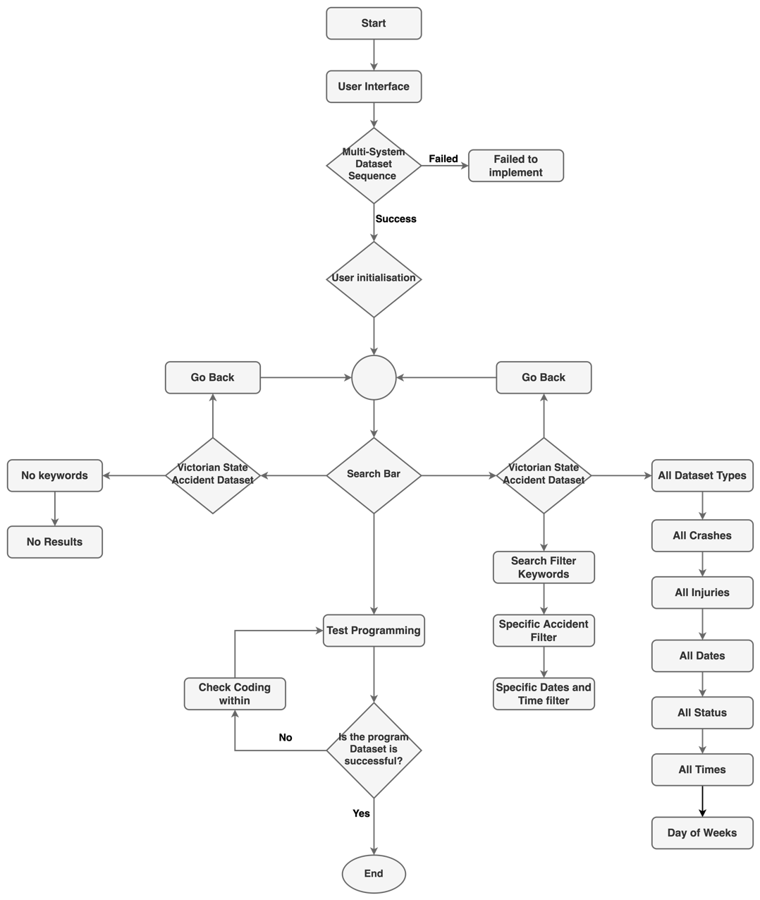

## System Components

### Functions

* The software validates the dataset on the Victorian State Accident that is shown in a table this will be the loadData function.
* The users should allow searching for all types of the accidents such as crashes, injuries, and status.
* The users should also be able to find the time when it occurs such as Dates, Days of the week, and Times, and the users can find the alcohol time which is shown in a chart.
* The software should be able to import the dataset in SQL into the system that represents itself in table rows.
* The users can search all types using keywords in the search filters along with the dates to see specific data in the table row.
* The software should be able to integrate with the banking API to perform the search keywords results for the users, this will be the function of displaying search results.
* The software system should be tested execution before non-functional testing.

### Data Structures / Data Sources

The following shows the list of all data structures that will be provided in the software:

* **Arrays:** This is the data structure which is the size-collection of elements of the same data type. This can reference the whole dataset of the Victorian State Accident so that the users can see the whole data in table rows.
* **Linked Lists:** This is the linear collection of the data elements in which order is not given by their physical placement. This can go towards the table rows within the data, meaning if the user can search keywords, the result can show the type and time zone of the accident.
* **Queues:** This part serves as a service that manages the website and app traffic peaks by offloading users to an online queue. This can go towards the search filter by using the keywords, dates and times showing users the result of the advanced searching tool.
* **Hash Tables:** This is the data structure that implements an associative array or dictionary that maps keys to its value. This can go in the dataset showing all the percentages of crashes such as the accident types and injuries of the DCA code that is in the table row.
* **Trees:** This part is the representation of the hierarchical tree structure which is connected to many nodes. This can go in the dataset showing all types of crashes such as types, status, date, time, and weeks. This is like the queues for the search filter.
* **Heaps:** This is the pre-served computer main storage that processes can use to store data in some variable amount that won’t start until the program is running. This can be when the user can see the whole table but not start when there is nothing typed in the search filter.

### Detailed Design

Pseudocode for all non-standard / non-trivial algorithms that operate on data structures

# User Interface Design

This is your initial interface design. Describe the tools you used for this design stage and any key findings that informed your design. This introduction is descriptive and should explain what you have completed for the actual design work you will present in the sub-sections below.

## Structural Design

Structural design refers to the navigational and information structure of your product – the structure that supports the interface layout. How will you structure your product? How will you group your information? How will you navigate through your product? Why? This can take the form of a diagram showing structure and hierarchy, supported by a discussion and justification of your choices. Why have you made these design choices? Describe and outline the structure of your interface and of your information.

## Visual Design

Detail your visual design: Layout, visual elements, icons, graphics, style, colour, fonts general screen designs. This can be sketches, wireframes, mockups etc, supported by a discussion, explanation, and justification of your choices.